LimeFEA-mPCIe_1v0 Gerber files definition:
Silk TOP - LimeFEA-mPCIe_1v0.GTO
Mask TOP - LimeFEA-mPCIe_1v0.GTS
TOP Layer - LimeFEA-mPCIe_1v0.GTL
Internal 1 – LimeFEA-mPCIe_1v0.G1
Internal 2 – LimeFEA-mPCIe_1v0.G2
BOTTOM Layer – LimeFEA-mPCIe_1v0.GBL
Mask BOTTOM – LimeFEA-mPCIe_1v0.GBS
Boarder – LimeFEA-mPCIe_1v0.GKO
NC drill:
“Top to Bottom” - plated – LimeFEA-mPCIe_1v0-Plated.TXT
“Top to Bottom” - non-plated – LimeFEA-mPCIe_1v0-NonPlated.TXT
Physical PCB Layers structure (for example):
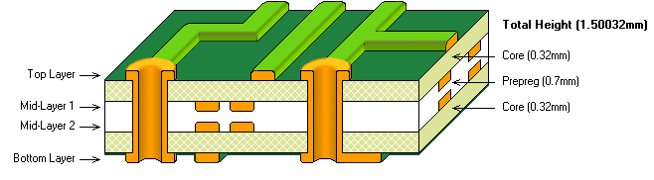
Outer Layer Copper Thickness 1oz/35μm
Inner Layer Copper Thickness 1oz/35μm
Overall Size - 100 x 70 mm ± 0.25 mm.
Finishing – gold plating, minimum thickness of 30 micro-inches for Edge Connector finger tabs and minimum 4 micro-inches for entire board.
PCB top layer material - IT-180A preferred or equivalent RF-rated material (up to 3 GHz or higher)
Edge connector thickness – 1.5 mm ± 0.1 mm.
Facets – 20° \|/ 20° x 1.4 mm for edge connector
Solder mask color – dark blue, glossy finish

